

### An INTERNSHIP REPORT

**On**

# “Digital Mall System”

Submitted to the faculty of

**Computer Science & Engineering,**

**Tatyasaheb Kore Institute of Engineering & Technology**

in partial fulfillment of the requirements for the Award of Degree of

### B.Tech. in

**Computer Science & Engineering**

Submitted By

### Mr. Sanket Sanjay Naik

**DEPARTMENT OF COMPUTER SCIENCE & ENGINEERING TATYASAHEB KORE INSTITUTE OF ENGINEERING AND**

### TECHNOLOGY, WARANANAGAR.

**Academic Year 2022 - 2023**



**TATYASAHEB KORE INSTITUTE OF ENGINEERING AND TECHNOLOGY, WARANANAGAR**

**DEPARTMENT OF COMPUTER SCIENCE ENGINEERING**

# CERTIFICATE

This is to certify that **Mr. Sanket Sanjay Naik (Roll No: 127, Class/Division: B)** has successfully completed Internship Course on “**Website development(Digital Mall System)**” in “**AIS Solutions Private Limited”** as partial fulfillment of the requirement for B.Tech. (Computer Science & Engineering) Semester-VI of Shivaji University, Kolhapur during the period from 05-Sept-2022 to 05-Oct-20222 in Academic year 2022-23.

#### Faculty Mentor/Supervisor Internship Coordinator

**Head**

#### Department of CSE PRINCIPAL

**Date: Place:**

# DECLARATION

To, HOD,

Department of Computer Science & Engineering, TKIET, Kolhapur.

Respected sir,

I undersigned here declare that the project module on “**Digital Mall System”** is developed by me in “**AIS Solutions Private Limited”**. I am declaring that this is my original work. I have not copied any material, which are useful to work or other reports that are submitted to the **“Department of Computer Science and Engineering, Tatyasaheb Kore Institute of Engineering and Technology, Warananagar”**. I am ready to face the consequences in way, college authorities may deem fit, if above matter proved to be false.

Yours faithfully,

**Sanket Sanjay Naik**

# ACKNOWLEDGEMENT

I take pleasure in presenting my internship work done in “**AIS Solutions Private Limited”** during the last **thirty days**. The internship period was an enriching experience for me from professional as well as personal front getting an opportunity to familiarize myself to the IT industry.

First, I would like to thank **Mr.Prajyot S. Patil** of “**AIS Solutions Private Limited”** for having faith in me and giving me the opportunity to work in their organization.

I wish to express my thanks to all in the company who have helped and guided me during this period. I would like to express my gratitude to HOD **Prof. R.B. Patil**, Internship Coordinator **Prof. K.N. Kamble**, Faculty Mentor/Supervisor **Name of Faculty Mentor/Supervisor** and entire Computer Science & Engineering department of Tatyasaheb Kore Institute of Engineering and Technology, Warananagar for their valuable guidance and support. I would also like to express my gratitude towards my colleagues and friends for the moral and technical support throughout the duration of my project.

Finally, this acknowledgement would be incomplete without rendering my sincere gratitude to all those who have helped me in the completion of presentation.

Sincerely,

**Sanket Sanjay Naik**

# INDEX

|  |  |  |
| --- | --- | --- |
| **Sr.No.** | **Content** | **Page No.** |
| 1. | Introduction |  |
|  | 1.1. Organization Overview |  |
|  | 1.2. Project Overview |  |
| 2. | Requirement analysis |  |
|  | 2.1 Functional Requirements |  |
|  | 2.2 Non-Functional Requirements |  |
|  | 2.3 System Requirements (Hardware and Software) |  |
| 3. | Software system Attributes (Technologies and Frameworks used) |  |
| 4. | System Design |  |
| 5. | Graphical User Interface (GUI) Snapshots |  |
| 6. | Conclusion |  |
| 7. | Bibliographies |  |
| 8. | **Appendix** |  |
|  | **I. Student internship program application** |  |
|  | **II. Request letter from institute to internship provider** |  |
|  | **III. Student Daily Diary (Log) Recordings** |  |
|  | **IV. Supervisor Evaluation of Intern** |  |
|  | **V. Student Feedback of Internship** |  |

## Introduction

### Organization Overview

AIS Solutions Pvt. Ltd. in Kothrud, Pune is a reliable name in the industry as they aim to deliver the best experience to their customers. This has helped them build up a loyal customer base. They started their journey in 2018 and ever since, they have ensured that the customer remains at the centre of their business operations and philosophy. As they are located in a favourable neighbourhood, exactly at Office No 305, 3rd Floor, Pandurang Apartment, Nr City Hospital, Opp Kachara Depot, Paud Road, Kothrud-411038 near Nr City Hospital, Opp Kachara Depot, it is easy to locate AIS Solutions Pvt. Ltd. on the map. For any kind of assistance or questions, it is best to contact them directly during their business hours.

Products or Services offered:

Also listed in Computer Training Institutes,Tutorials, Tutorials For Share Trading, ShareBrokers, Education Consultants etc. AIS Solutions Pvt. Ltd. in Kothrud is one of the most trustworthy names in the field. They have received a 4.8 rating from their customers. To make the transactional experience hassle free for customers.

### Project Overview

During the internship they have assigned some tasks. The below information is regarding to the tasks :

So as project we have been given tasks to perform .The task tends to completing of a website.The website is related to restaurant management system and Digital mall System.So it was upto us what we want to design but design and development methodology was same.

So tasks are as follows-

1. The first assignment consist of setuping and install mySql database.We have studied aboud types of database,redundacy ,what is tuple and study of student course database system
2. In the second assignment we have studied about users of database and interfaces they need we have drawn and implemented dbms architecture for airline reservation system .So in this we have used three tier client-server architecture
3. In this section we have studied about constraints in database to study this we have studied example of student course database
4. Along with that we have studied dtabase schema and database state.When we define a new database, we specify its database schema only to the DBMS.
5. The Web Server contains the application logic which includes all the rules and regulations related to the reservation process and the issue of tickets; the Database Server contains the DBMS.
6. In this assignment, we will create two tables. One will be assigned an ID and the other will be assigned to a CLASS. We will style the tables differently. One will use ID-based style rules and the other will use CLASS-based

style rules.

### Functional Requirements :

* Admin has access to monitor everything in the restaurant system or digital mall system.
* Admin can add, update all the orders of the restaurant system or digital mall.
* The customer can view items (Laptop,iPad & Computers ) and then finally add items to the shopping cart and order the same.
* We have created data entry form on one of our website page for visitors who want to be added to mailing list.We have used radio buttons ,check boxes and element with options.

### Non-Functional Requirements :

The Database may get crashed or damaged due to some viruses or operating system requirements.

* System will use secure Database.
* Proper user Authentication will be provided.
* There should be separate account for Admin & User. So that no one else can access the database except Admin.

### System Requirements (Hardware and Software) Software Requirements

Operating System: Linux,Windows -7,8,10,11

Coding Language: HTML, CSS, JavaScript,

Text Editor: Notepad.

### Hardware Requirements:

Processor : Intel core i3 or Latest

Memory : 2GB RAM or more

Hard Disk : 512 GB

## Software system Attributes (Technologies and Frameworks used)

Various tools and technology were used during our internship training. Some of them are listed below:

1. HTML5

HTML stands for Hyper Text Mark-up Language. It is used to design web pages using mark-up language. HTML is the combination of Hypertext and Mark-up language. Hypertext defines the link between the web pages. Mark-up language is used to define the text document within tag which defines the structure of web pages.

1. CSS3: •

Cascading Style Sheet (CSS) is a style sheet language that specifies how to incorporate style information in a style sheet. • The term ‘cascading’ indicates that several style sheets can be blended to present a document on the browser’s screen.

1. JavaScript:

* It is a scripting language and supports client side scripting.
* It is an interpreted language.
* It was developed by Netscape Corporation.
* Initially it was known as “Live Script”
* It was designed to add interactivity to HTML pages.
* It also supports server-side scripting, separately known as Livewire.

## 3.System Design

## Component Diagram

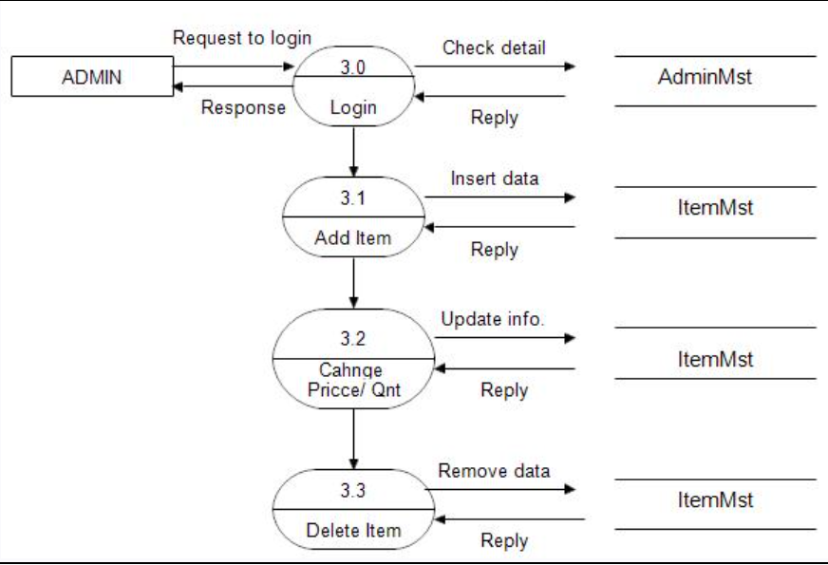

### Detailed Design of Implementation

This phase of the systems development life cycle refines hardware and software specifications, establishes programming plans, trains users and implements extensive testing procedures, to evaluate design and operating specifications and/or provide the basis for further modification.

#### Technical Design

This activity builds upon specifications produced during new system design, adding detailed technical specifications and documentation.

#### Test Specifications and Planning

This activity prepares detailed test specifications for individual modules and programs, job streams, subsystems, and for the system as a whole.

#### Programming and Testing

This activity encompasses actual development, writing and testing of program of user training materials, conducting training programs, and testing procedures.

#### Acceptance Test

A final procedural review to demonstrate a system and secure user approval before a system becomes operational.

#### Review Phase

This phase evaluates the successes and failures during a system development project, and to measure the results of a new Computerized Transystem in terms of benefits and savings projected at the start of the project.

## Graphical User Interface (GUI) Snapshots

Home :

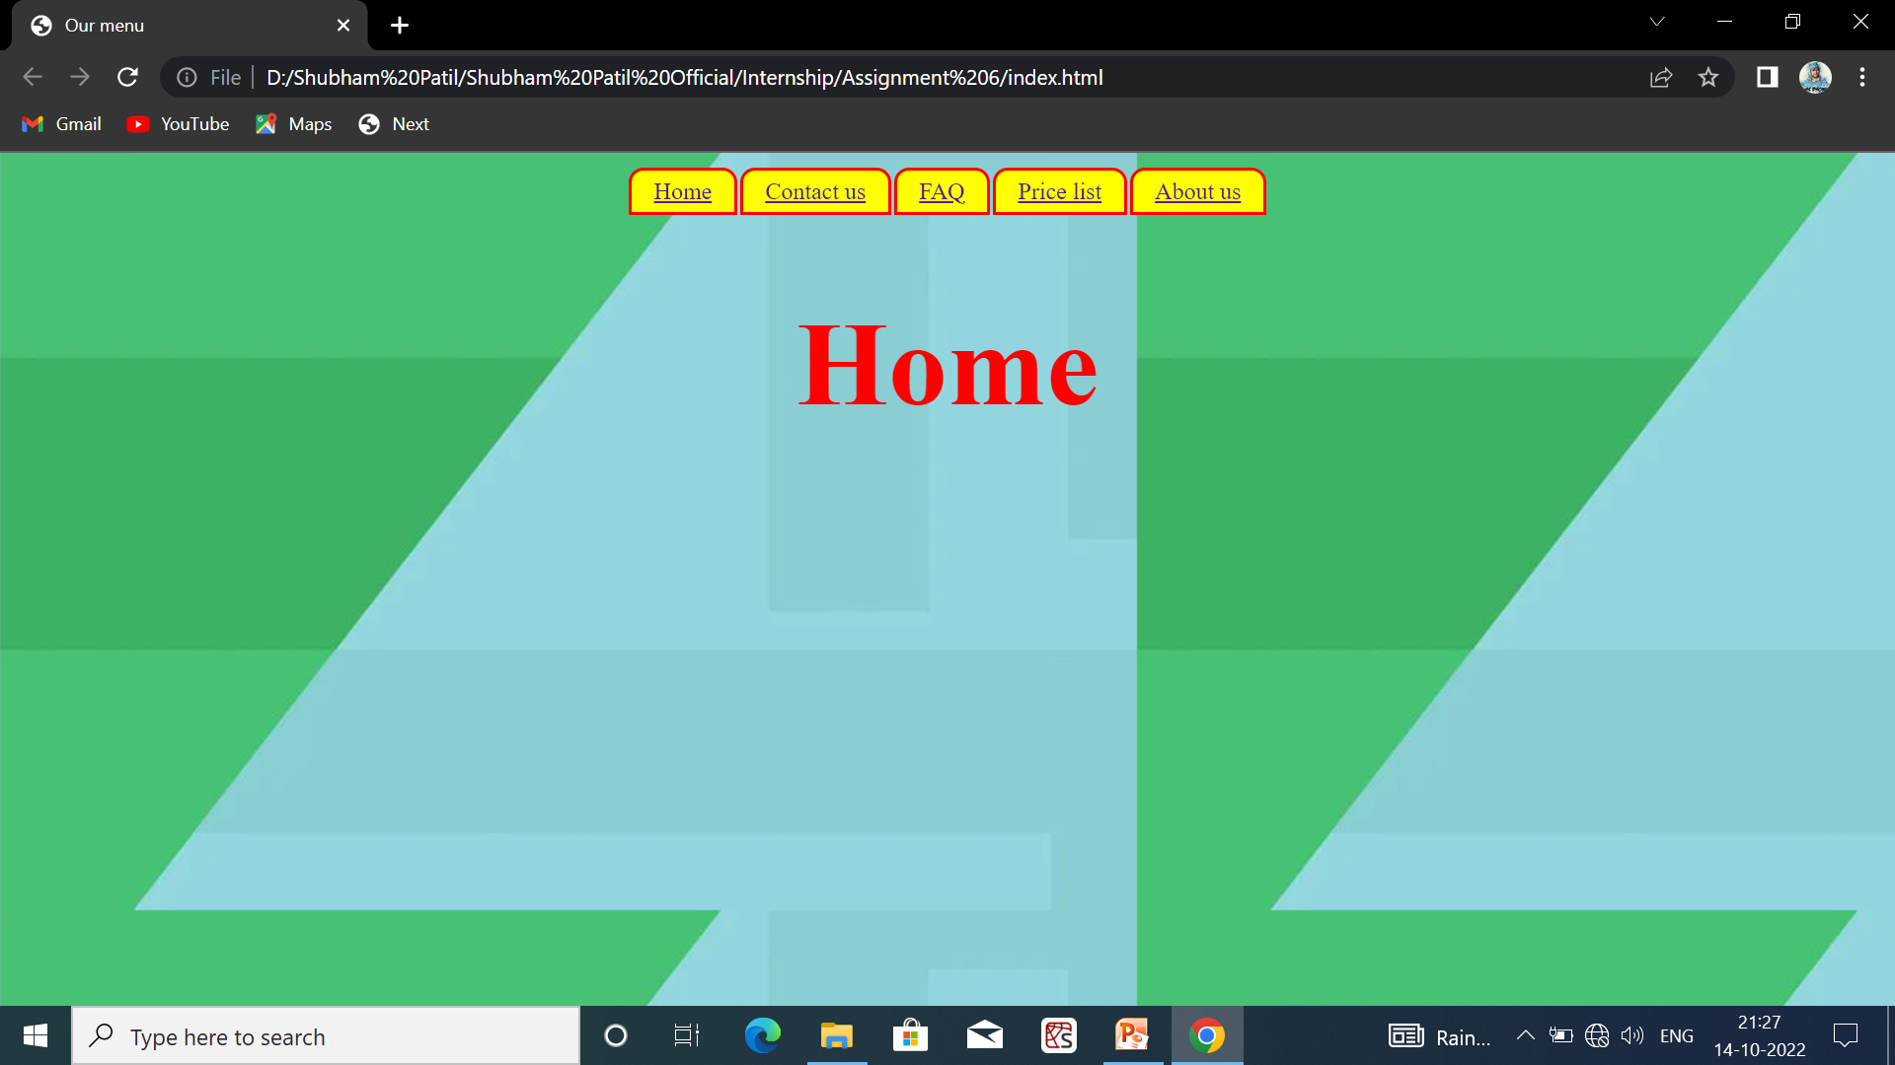

Price List Page :

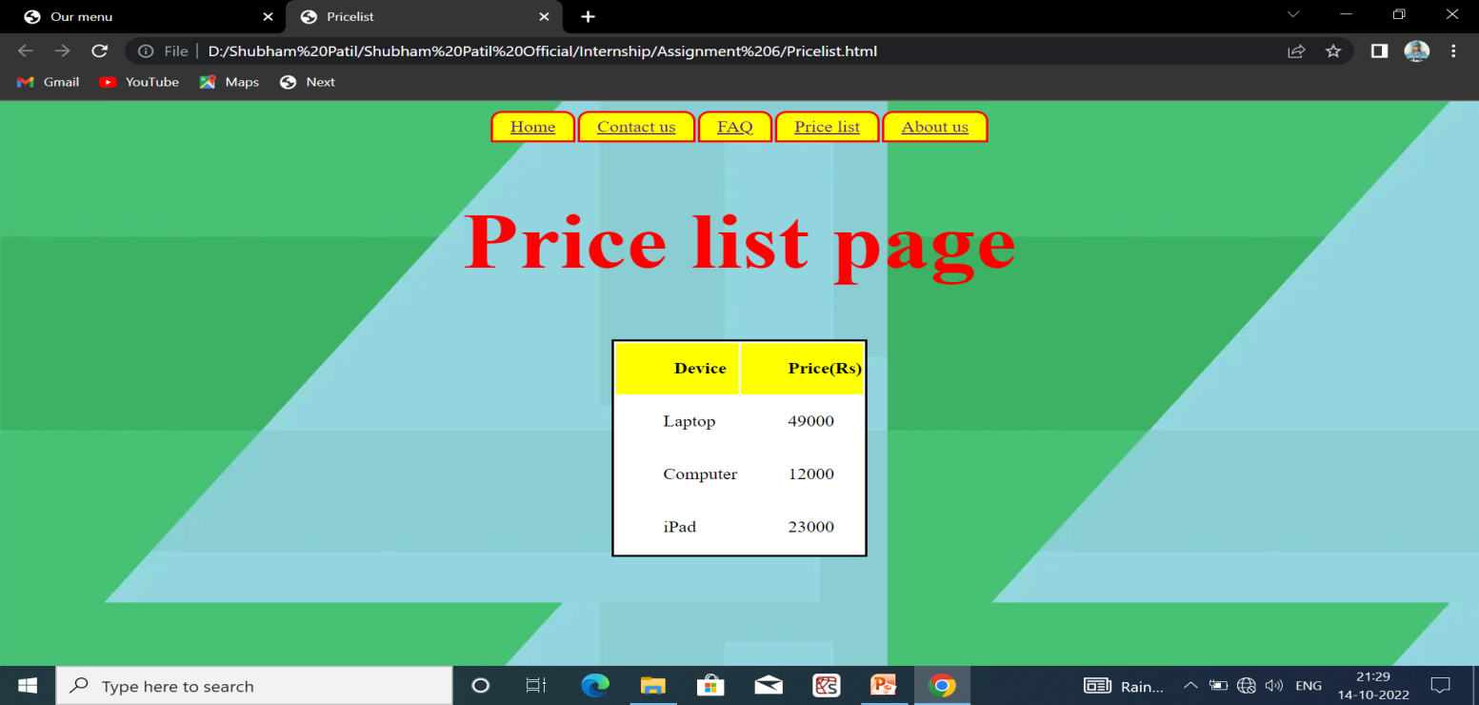

About Us:

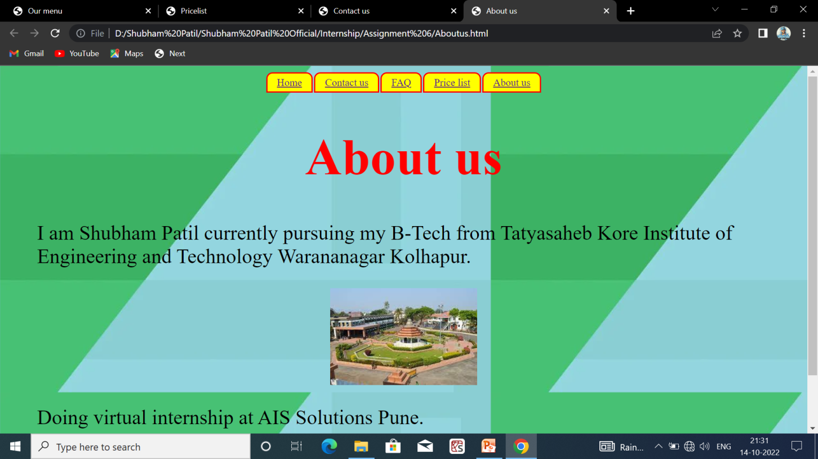

## Conclusion :

During the internship I have learned about frontend web development

and how the actually we can design the website as industry level. Also learned about the technologies (HTML,CSS, JavaScript) which is used to Design the websites.

I learned to live in a different environment from the one I am used to. Indeed, I grew more independent in work and also in everyday life. I realized that I could do more things than I thought, like learning new things by myself.

## Bibliographies

* + <https://www.w3schools.com>
  + <https://www.wikipidea.com>
  + <https://www.w3.org/standards/semanticweb/>
  + <https://developer.mozilla.org/en/docs>
  + <https://sioc-project.org/ontology>
  + <https://janastu.org>